**Sacred Heart Parish Yea – 3rd November 2024**

**31st Sunday of Ordinary Time**

**SAINTS FOR THIS WEEK: ST JOACHIM & ST ANNE**

**Recently Deceased**: We keep in our prayers all recently deceased, and those who’s anniversaries occur around this time, that they dwell for ever in God’s loving embrace. Lord Hear Us.

**Anniversaries**: Sheryl Baynes, Mary Searle-Walker, Monica Slevin, Bill Collons, Roma Long, Wayne Nicholson, Ray Alen, Geraldins Purvis, Arthur Sullivan, Nora Forde, John Peter (Jack) Mahon and Miriam Ena Taylor.

|  |  |  |  |  |
| --- | --- | --- | --- | --- |
| **Collections last Sunday** | | |  |  |
| Presbytery Account | | $287.00 | Direct Credit | $0 |
| Church Account  Special Contribution | | $284.00  $0.00 | Direct Credit | $0 |
| **Church Deposits by Direct Credit** | | | |  |
| **Presbytery Account –** for the welfare of bishops and priests | | | | |
| **Sacred Heart Presbytery Account** | | | |  |
| BSB | 633 000 | | Account number | 150 264 992 |
| **Church Account –** for our parish, its mission, welfare and maintenance: | | | | |
| **Sacred Heart Church Account –** for our Priests | | | |  |
| BSB | 633 000 | | Account number | 150 264 778 |

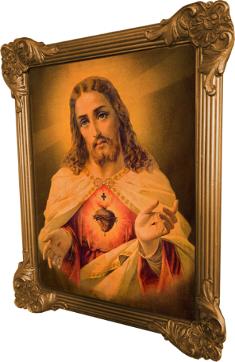**Prayers for those who are sick:** Kate Pittle, Barbara O’Donnell, Rod McKenzie, Michael Tomlinson, Tony Dwyer, Julie Mahony, David Heath, Monika Matteo, Jack (Graeme) McMaster and John Finnity.

|  |  |  |  |  |  |
| --- | --- | --- | --- | --- | --- |
| **Roster** | **Readers** | | **Prayers** | **Counter** | **Flowers** |
| 3rd Nov 2024 | J. Anderson, M. Mahon | E. McAleer | | E. McAleer | J. Anderson |
| 10th Nov 2024 | A. Finn, M. Sheather | P. O’Connor | | M. Sheather | M. Lockhart |

**The Holy Father’s new encyclical calls the faithful to embody Christ’s heart of love and service in their daily lives, emphasizing the transformative power of the Holy Spirit.**

Pope Francis invites us to gaze upon the heart of Christ, a heart that reveals the depth and beauty of God’s love in his new encyclical [Dilexit Nos](https://www.vatican.va/content/francesco/en/encyclicals/documents/20241024-enciclica-dilexit-nos.html) (He Loved Us). <https://www.vatican.va/content/francesco/en/encyclicals/documents/20241024-enciclica-dilexit-nos.html> This is no distant or abstract love, but a love that reaches down to meet us in our humanity, in the messiness of daily life and in the quiet longings of our hearts.

For the laity, this call to love is especially significant. While ordained ministry has a distinct, vital role within the Church’s hierarchy, Dilexit Nos reminds us that the call to serve as Christ the Servant extends to all the baptized. Baptism marks the entry into a vocation of love and service, one that transcends the boundaries of the sanctuary and reaches into every corner of life, work, community and beyond. The heart of Christ becomes the model for a spirituality that is not reserved only for the clergy but is meant to permeate and penetrate the life of every Christian.

**5 Key Takeaways**

Dilexit Nos offers a profound reflection on the love of Christ and its implications for the life of the laity. It calls the faithful to embody Christ’s heart of love and service in their daily lives, emphasizing the transformative power of the Holy Spirit. There are five key takeaways from the encyclical which will be looked at in next Sunday’s Bulletin.

**Sacred Heart Parish Yea**

Established 1890

Email: [yea@cam.org.au](mailto:yea@cam.org.au)

Phone: (03) 5899 9128

P.O. Box 61 YEA 3717

Website: www.shyea.catholic.edu.au

**Holy Mass Times**

Yea –Sunday 10:45am, Tuesday 5:00pm and Rosary, Thursday 9:00am

Alexandra – Sunday 8:45am, Wednesday 9:30am, Friday 9:00am

Parish Priest:

**Fr Jose Mathew** 0459 402 547

Secretary:   
**Sacred Heart Primary School**  
Principal: Kathryn Stuart

03 5797 2723

Reconciliation: **Fr Jose Mathew** 0459 402 547

Yea – Tuesday before Mass from 4:30pm and Sunday after Holy Mass approximately at 11:45am

Alexandra – Friday before Holy Mass and before Sunday Holy Mass from 8am